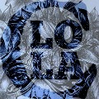

**June**

15

**LOLA COLLECTIVE.**

08

**Fall**

*“The Brisbane art scene has a new address.”*

**LOLA COLLECTIVE**

Business Plan

2015 - 2018

**Submitted to: The Financial Group**

**Submitted by:** Elizabeth Weigh, Rifqui Ryan, Jiarui Han

Lola Collective, Inc.

**Date:** June, 2015

**EXECUTIVE SUMMARY**

The Executive Summary captures the reader’s interest and covers some key areas from your Business Plan. Include everything that you would cover in a five-minute interview. Explain the fundamentals of the proposed business: What will your product be? Who will your customers be? Who are the owners? What do you think the future holds for your business and your industry? Make it enthusiastic, professional, complete, and **concise**.

**TABLE OF CONTENTS**

**TOPIC PAGE**

**Executive Summary** 2

**Mission Statement** 4

**Business Description** 5

**Products and Services** 6

**Market Analysis**  7

**Competitor Analysis** 8

**Management and Staf**f 9

**Risks and Challenges** 10

**Benefits** 11

**Financial Plan** 12

**Appendix A**

**Appendix B**

**Appendix C**

**Appendix D**

**MISSION STATEMENT**

**Lola Collective**

At Lola Collective, we seek to discover emerging Brisbane-based artists whose pieces are inspired and bursting with individuality and soul, and retail these to customers’ searching for unique works of art. Ultimately, we are dedicated to connecting passionate artists and art aficionados alike, and expand the breadth of talent in, and, eccentricity of, the Brisbane art scene.

**COMPANY DESCRIPTION**

Lola Collective will operate as an online art gallery and retailer in the arts and culture sector. Essentially, Lola Collective will function as seller of artist’s works and, furthermore, provide marketing and promotion services to artists whose works are sold, and ideals are featured, through the online store.

The commercial retailing of artworks is a well-established industry, with Australian household spending on visual arts continuing to grow over time. According to a study of ‘Household Expenditure’ conducted by the Australian Bureau of Statistics (ABS), spending on visual arts has grown by 26% since 2004. Furthermore, due to the rampant growth of the Internet as a medium for connecting and communicating with a wider virtual community, the commercial arts industry has been subject to much change. Following an Internet penetration rate of 80% in Australia, as at August 2009, it is evident that the Internet has become an inextricable component of all facets of Australian society. **(REF)** With regard to the commercial art scene, the Internet has triggered a fundamental shift in the way that Australian’s consume and seek information regarding the industry, as a whole. As such, the Internet is a critical and innovative medium of communication, and at Lola Collective, we believe that it is imperative to adopt a progressive business approach and align the Brisbane art scene with this sweeping popularity of the Internet and online processing.

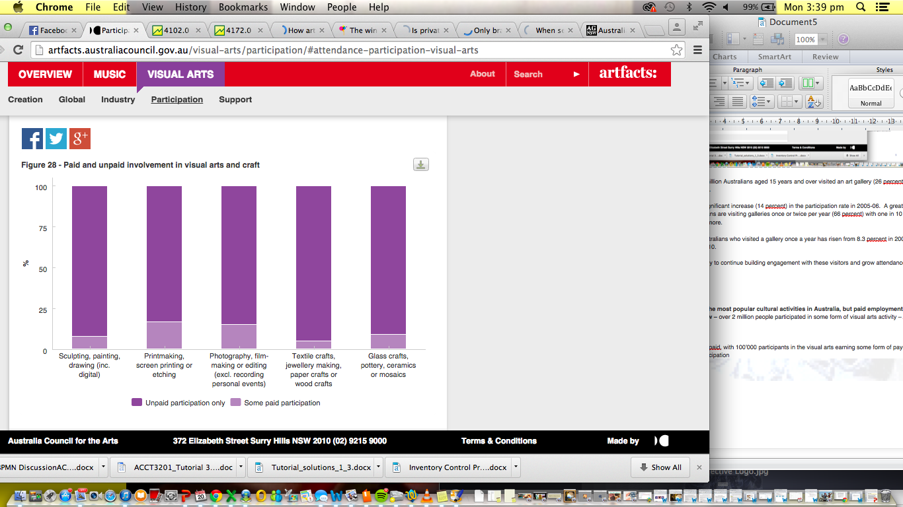

At present, a large portion of Brisbane’s emerging and undiscovered artists are unable to have their works formally recognized in art galleries (due to a lack of awareness and prestige), and struggle to promote and sell their works through their own media channels.

<http://www.abs.gov.au/AUSSTATS/abs@.nsf/Lookup/4102.0Main+Features40Jun+2011>

**3 or 4 factors that will make the buisneess succeed 🡪**

**-- Online platform – much more interest in 2 way communication between consumers and artists**

**-- The convenience of web browsing for consumers -**

**-- Benefit to artists – allows them a greater medium and platform to market their works and their brand – in a gallery rather limited to walk-in crowds**

**Australian household spending on visual arts has been subject to growth over time –** we now spend over $100 annually on paintings, carvings, sculptures etc – 26% increase on 2003-04 levels in real terms 🡪 [ABS 2011 ‘Household Expenditure Survey, Australia: Summary of Results (6530.0)](http://www.abs.gov.au/AUSSTATS/abs@.nsf/mf/6530.0/" \t "_blank)

Statistics and Trends

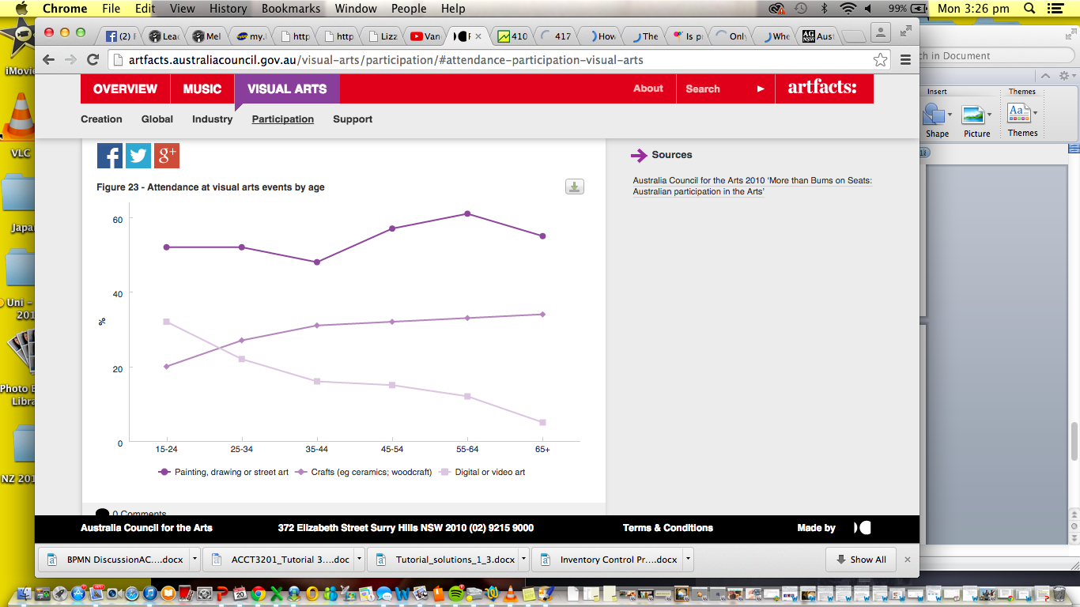

**Source:** Australian Council for the Arts 2010 ‘More than Bums on Seats: Australian participation in the Arts’

**Source: ABS 2010 ‘Attendance at selected cultural venues and events 2009-10’ (CATI 4114.0)**

**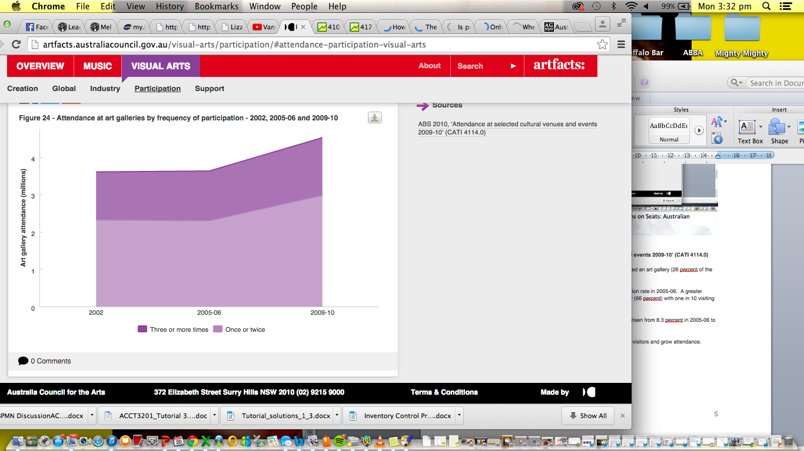**

In 2009-10 over 4.5 million Australians aged 15 years and over visited an art gallery (26 percent of the Australian population).

This represented a significant increase (14 percent) in the participation rate in 2005-06.  A greater proportion of Australians are visiting galleries once or twice per year (66 percent) with one in 10 visiting galleries six times or more.

The proportion of Australians who visited a gallery once a year has risen from 8.3 percent in 2005-06 to 10.4 percent in 2009-10.

There is an opportunity to continue building engagement with these visitors and grow attendance.

**Visual art is one of the most popular cultural activities in Australia, but paid employment opportunities are low –** over 2 million people participated in some form of visual arts activity – alsmost 1.25 million

Most involvement is upaid, with 100’000 participants in the visual arts earning some form of payment for their contribution/participation



**Australian household spending on visual arts has been subject to growth over time –** we now spend over $100 annually on paintings, carvings, sculptures etc – 26% increase on 2003-04 levels in real terms 🡪 [ABS 2011 ‘Household Expenditure Survey, Australia: Summary of Results (6530.0)](http://www.abs.gov.au/AUSSTATS/abs@.nsf/mf/6530.0/" \t "_blank)

**Commercial Art Galleries, Australia, 1999-2000** [**http://www.abs.gov.au/ausstats/abs@.nsf/mf/8651.0**](http://www.abs.gov.au/ausstats/abs@.nsf/mf/8651.0)

**Artists representing on an on-going basis at end June 17,366 16,949 (-2.4%)**

**Commission from the sale of artworks – 25.7 million to 43.4 mill (+68.9%)**

**http://www.abs.gov.au/ausstats/abs@.nsf/mf/8651.0**

<http://www.abs.gov.au/AUSSTATS/abs@.nsf/Lookup/4102.0Main+Features40Jun+2011>

3. The internet is a key tool for the arts One in three Australians are already using the internet for the arts- mostly for attendancerelated activities (such as researching artists/events or downloading music), but some are using it for creative participation (such as posting works of art, writing blogs or working with others to create art).

More than half of all 15-24 year olds had used the internet to engage in some form of art during the last year and were more creative online than others. The most widespread online art creations are writing and visual art/film/video, while the most frequent mode of creative participation is being involved in an online community or social network concerned with art in some way.

🡪Consumers 39% of all internet users

🡪Creators 16% of all internet users

Creators are more likely to be: • 15-24 years • Highly engaged: both participating & attending • Attending Indigenous arts • High school or tertiary students • Really like the arts Consumers are more likely to be: • 35-64 years • Attending only • Not attending Indigenous arts • In full time paid employment, carring out home duties or retired • Like or neither like or dislike the arts

• The lovers (38%) are highly engaged with the arts and see the arts as an integral part of their lifestyle. They also hold the view that the arts provide them with a more meaningful and richer life as well as help them feel part of their local community. ustralian participation in the arts.

The flirters (26%) are more likely to be influenced to attend arts events by their friends than the ‘The lovers’. They like the arts, but are not necessarily convinced that they help them feel part of their local community. However they strongly believe that the arts provide a way of saying important things that need to be said in our society.

• The un-attached (19%) are those who have a neutral attitude towards the arts- many have not actually participated in, or attended any, of the main art forms in the past year, and some have never experienced these art forms at all. While they do not dislike the arts per se they just cannot see the personal relevance of the arts to them.

• The outsiders (17%) believe the arts tend to attract people who are pretentious and elitist. They believe the arts require a reasonable level of understanding to appreciate them fully and therefore the arts are “not for them”.

Each of these segments can increase their level of engagement with the arts, although the strategies to stimulate demand vary.

For example even ‘The lovers’ have a significant sub-segment with no to low attendance. The strategy needed here is to encourage habit forming attendance. This segment want to attend and participate, they really like the arts but a claimed lack of time and awareness of upcoming events prevents attendance.

Half ‘The flirters’ attend frequently and this positive behaviour needs to be reinforced to ensure the frequent arts attendance continues.

The majority of ‘The un-attached’ are more difficult to reach. They need to be tempted by arts offers and information that relates to them and stimulates their interest.

Lastly, ‘The outsiders’ need to be convinced why the arts should be on their agenda. These four distinct ‘mindsets’ were then crossed with the levels of attendance to produce nine segments based on attitudes and behaviours.

Each of these community segments will demand different marketing and policy responses from arts organisations looking to build audiences. The full report details strategic insights and potential responses to each of these segments.

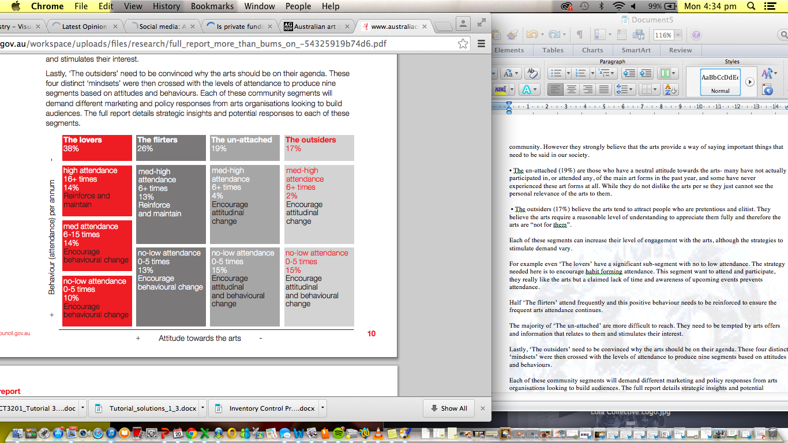

**The arts and the internet**

**🡪Almost a third of all people** had used the internet to research, view or create some kni

🡪Youth were much more likely to use the internet for the arts

🡪Stakeholders interviewed said that the internet was impacing on their target audiences and their art – felt that new audiences were emerging and thorugh that the internet, in some way, was the cause.

🡪Internet penetration rate of 80% in Australia as at August 2009, the world wide web has become an inextricable part of people’s lives and has transformed the way they consumed and sought information about the arts.

🡪Increased activity with arts audiences through the use of blogs, forums and wikis – encourage 2 way communicaitona dn the sharing of information

🡪Typical obstacles – such as lack of exposure, awareness, time and cost, can be mitigated through the use of the internet – potential to dissolve many of the barriers people experienced while attepting to engage in the arts – positive environment for people to trial the arts without having to physically attend --?also a supportive environment for new art forms – e.g. digital art.

Generation Y – confident, educated, wealthy, and experience-seeking cohort, appear to be taking advantage of the endless possibilities presented by teaming of two opposing realms – technological (internt) and creative (arts)

39% of internet users were consuming (rather than creating) art online by researching, watching/listening to, or downloading different art fomrs 🡪technology has seemed to increase the spontaneity of arts consumers

The most common use of the internet was to discover/research an artit or event (32% of all internet users) 🡪art enthusiasts using the internet as a mechanism for increasing their knowledge and awareness of different artists/styels and events occurring.